Hands-on 3.1: Error Wrapping & Context

1. Prerequisites & Setup
We will simulate a database failure to see how wrapping works across different layers of your code.
Run these commands in your terminal:
# 1. Create the project root
mkdir 03_error_lab
cd 03_error_lab
# 2. Initialize the module
go mod init error-context-lab
# 3. Create package folders
mkdir db
mkdir service

2. Why are we doing this?
In a modular system, an error might start at the Database layer, pass through the Service layer, and finally reach the User.
- The Problem: If the service just returns a new error, you lose the database details.
- The Solution: We use the %w verb (wrapping) to build a "Russian Nesting Doll" of errors. This allows the top layer to use errors.As() to "unwrap" the chain and find the original specific error type.

Part 1: The Low-Level Database Error
Create db/database.go. Here we define a custom error type that represents a database connection failure.
package db
import "fmt"
// DBError is a custom error type
type DBError struct {
Query string
Err error
}
// Error makes DBError satisfy the error interface
func (e *DBError) Error() string {
return fmt.Sprintf("database error on query '%s': %v", e.Query, e.Err)
}
func FetchUser(id int) error {
// Simulating a connection failure
return &DBError{
Query: "SELECT * FROM users WHERE id=?",
Err: fmt.Errorf("connection refused"),
}
}

Part 2: The Business Service (The Wrapper)
Create service/user_service.go. This layer adds Context using the %w verb.
package service
import (
"error-context-lab/db"
"fmt"
)
func GetUserProfile(id int) error {
err := db.FetchUser(id)
if err != nil {
// We WRAP the low-level error with business context
return fmt.Errorf("failed to load user profile (ID %d): %w", id, err)
}
return nil
}

Part 3: The Main Entry Point (The Inspector)
Create main.go in the root folder. Here we use errors.As() to extract the original DBError from the wrapped chain.
package main
import (
"error-context-lab/db"
"error-context-lab/service"
"errors"
"fmt"
)
func main() {
fmt.Println("=== ERROR WRAPPING & CONTEXT LAB ===")
err := service.GetUserProfile(101)
if err != nil {
// 1. Show the full "wrapped" error message
fmt.Printf("Full Error Chain:\n%v\n\n", err)
// 2. Use errors.As to find the original DBError cause
var databaseErr *db.DBError
if errors.As(err, &databaseErr) {
fmt.Println("--- Original Cause Extracted ---")
fmt.Printf("Detected specific DB Failure!\n")
fmt.Printf("Failed Query: %s\n", databaseErr.Query)
} else {
fmt.Println("Unknown error type encountered.")
}
}
}

Execution & Verification
Run the project:
go run main.go

What you will see:
=== ERROR WRAPPING & CONTEXT LAB ===
Full Error Chain:
failed to load user profile (ID 101): database error on query 'SELECT * FROM users WHERE id=?': connection refused
--- Original Cause Extracted ---
Detected specific DB Failure!
Failed Query: SELECT * FROM users WHERE id=?

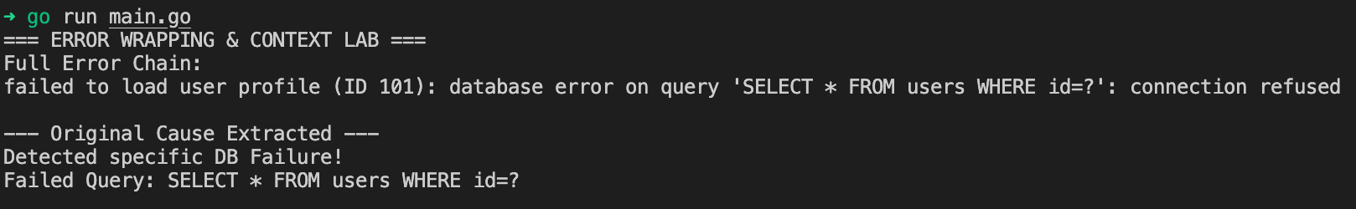

Congratulations!
Congratulations! You have mastered Production-Grade Error Handling.
By using %w and errors.As(), you have ensured that your application doesn't just crash blindly. You can now pass errors through 10 layers of code while still being able to "look inside" and see exactly what happened at the very bottom.

